Professional Readiness for

Innovation, Employability

And Entrepreneurship

Smart home

Submitted by

H.Raseena Barwin

961819106043

B12-6A2E

MOTION DETECTION USING IR SENSOR

CODE

int pirsensor =0;

void setup()

{

pinMode(2, INPUT);

pinMode(12, OUTPUT);

pinMode(13, OUTPUT);

}

void loop()

{

pirsensor = digitalRead(2);

if(pirsensor == HIGH)

{

//glow led

digitalWrite(13,HIGH);

// ring buzzer

tone(12,500,500);

}

digitalWrite(13,LOW);

}

TINKER CARD LINK:

<https://www.tinkercad.com/things/buUzLddBZbx>

FIGURE: 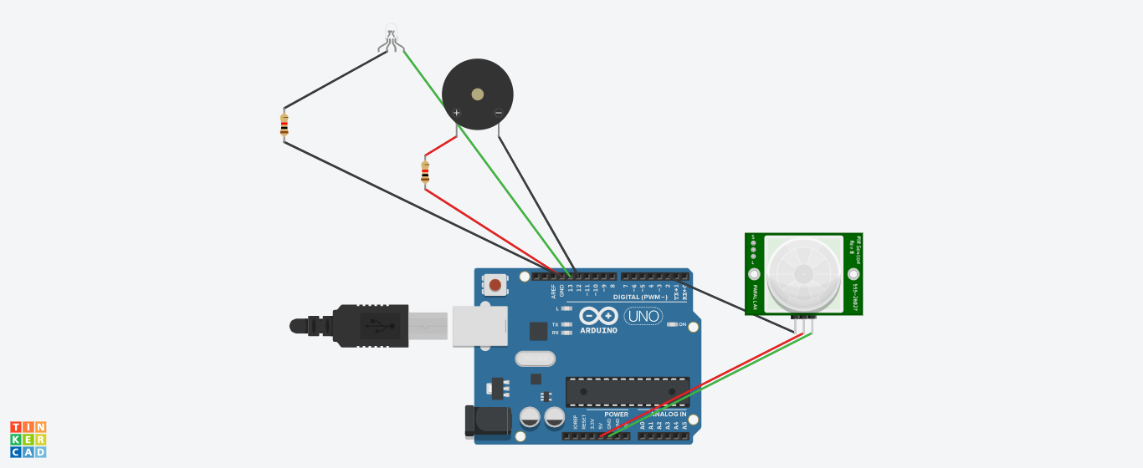

Whenever anyone comes in the path or range of IR sensor, microcontroller detects the distance of object from the sensor and if the object is in the defined range it sends the High signal to buzzer and buzzer starts beeping at the same time light is emitting.